Session-1 Lab Program

1.Common Elements Between Two Array

Code:
arr1 = [1, 2, 3, 4, 5]
arr2 = [3, 4, 5, 6, 7]
common = []
for x in arr1:
if x in arr2:
common.append(x)
print(common)

Output:
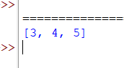

2. First Palindromic String in an Array
Code:
arr = ["abc", "car", "ada", "racecar", "cool"]
for word in arr:
if word == word[::-1]:
print("First Palindromic String:", word)
break
else:
print("No Palindromic String")

Output:
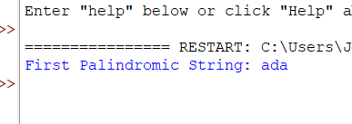

3. Subarrays Distinct Element Sum of Squares
Code:
arr = [1, 2, 1]
total = 0
for i in range(len(arr)):
distinct = set()
for j in range(i, len(arr)):
distinct.add(arr[j])
total += len(distinct) ** 2
print("Sum of squares:", total)

Output:
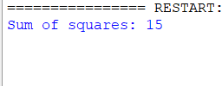

4. Count Equal and Divisible Pairs in an Array
Code:
arr = [3, 1, 2, 3, 1, 3]
k = 2
count = 0

for i in range(len(arr)):
for j in range(i + 1, len(arr)):
if arr[i] == arr[j] and (i * j) % k == 0:
count += 1
print("Count:", count)

Output:
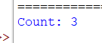

5. Maximum Element with Least Time Complexity
Code:
arr = [10, 25, 7, 45, 32, 18]
maximum = arr[0]
for i in range(1, len(arr)):
if arr[i] > maximum:
maximum = arr[i]
print("Maximum element:", maximum)

Output:
